FOCP ASSIGNMENT 1

MODULE 4
Ques 3
subtract product and sum
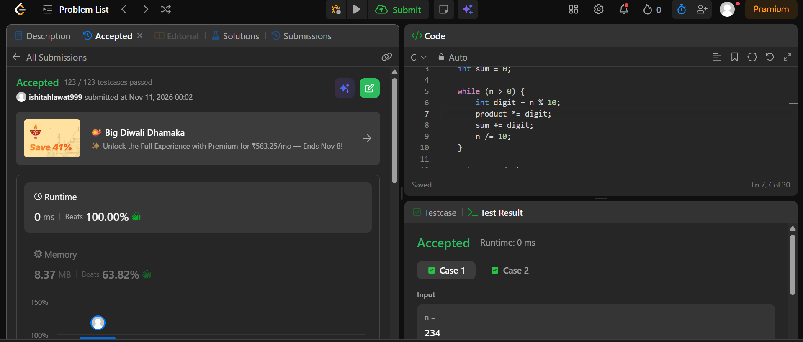

int subtractProductAndSum(int n) {
int product = 1;
int sum = 0;

while (n > 0) {
int digit = n % 10;
product *= digit;
sum += digit;
n /= 10;
}

return product - sum;
}

